**The Shoot 'Em Up Program**

**DEFINE THE PROBLEM**

This program will run a game where the player controls a character named Jake English and tries to shoot oncoming enemies. The player will be able to move their character left and right, and tell the character when to fire. The player will collect points for each enemy they hit, and will lose a life each time that they are hit. If they lose all of their lives, it will be game over! The program will have a high score component when the game ends where it calls scores from a notepad document, and adds the score to a list which is arranged by highest to lowest. The list will show the 10 highest scores.

**User Interface**

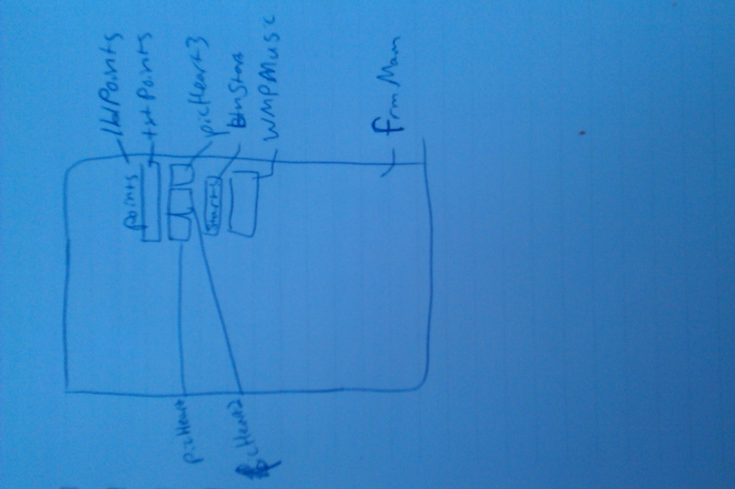

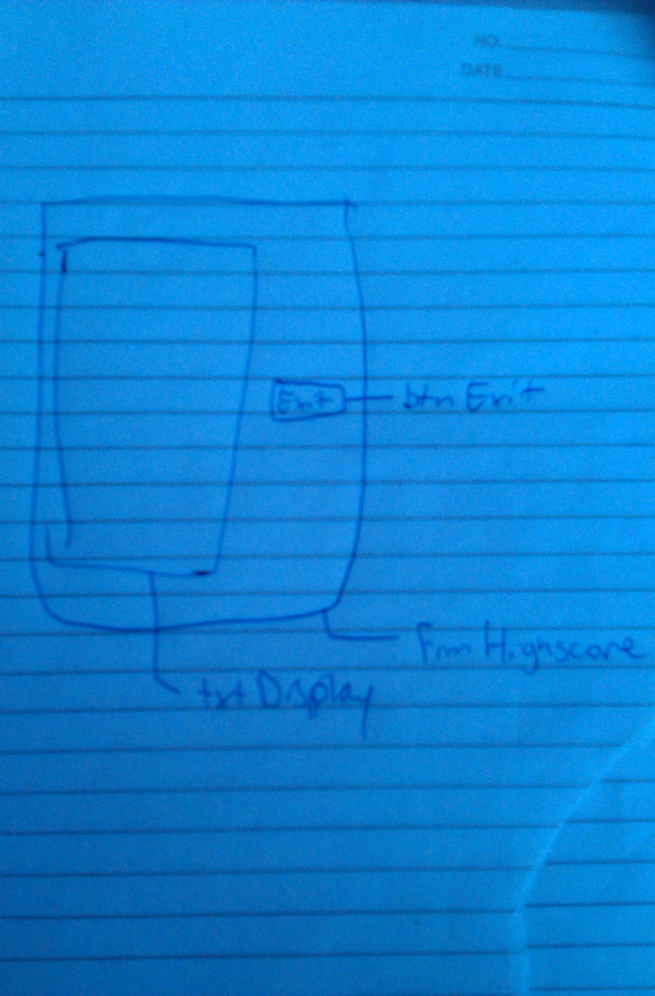

**Form Settings**

|  |  |  |  |
| --- | --- | --- | --- |
| Control Object Type | Property | Setting | Purpose |
| Form | Name  Caption | FrmMain  Shoot 'Em Up! | The form where the game is played  Displays the game's Title |
| Form | Name  Caption | FrmHiscore  Highscores | The form that opens when the game ends. It shows high scores, and adds the player's score. |
| Label | Name  Caption | lblPoints  Points | Label above the textbox that shows Points gained |
| Text Box | Name  Caption | txtPoints  (EMPTY) | Text box where points are displayed |
| Text Box | Name  Caption | txtDisplay  (EMPTY) | Text box where the high scores are displayed |
| Button | Name  Caption | btnStart  START/STOP | The button which starts and stops the game |
| Music Player | Name | WMPMusic | Allows music to be played in the game |
| Picture | Name | picHeart | Displays lives left |
| Picture | Name | picHeart2 | Displays lives left |
| Picture | Name | picHeart3 | Displays lives left |

**GENERAL SPECIFICATIONS FOR PROJECT**

**GENERAL INFORMATION**

**Application Name:** Shoot 'Em Up

**Date Created:** December 2013-January 2014

**Programmer:** Adele Olejarz

**LIST OF FILENAMES**

**Project File:** ShootEmUp

**Form1:** FrmMain

**Form2:** FrmHighscore

**Class:** GlobalClass